FOR IMMEDIATE RELEASE: 16 July 2019
Robert Tillsley
Black Sky Books
0448 242 496
robert@blackskybooks.com

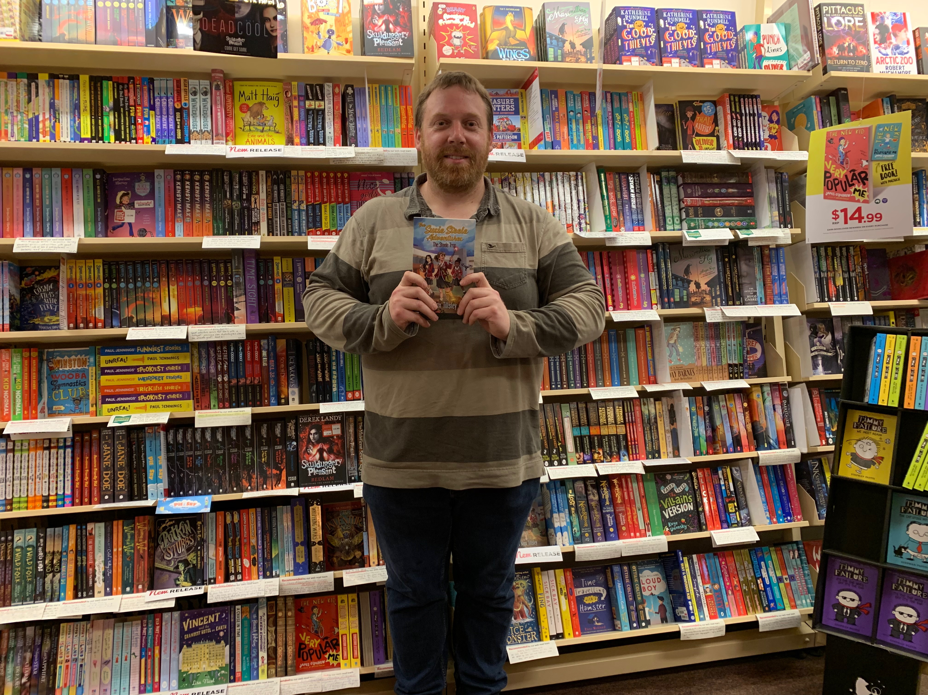

Local author born from search for stories for his daughter

Magill author R Max Tillsley is set to launch his debut children’s novel The Steele Trap this weekend at Hutt Street creative co-working space Vault 134.

Inspired by the challenge to find exciting tales for his daughter Heather, Tillsley carried his trusty laptop to libraries and cafés across Adelaide until the first book of Susie Steele’s adventures was born.

“Girls love to read stories filled with magic, action and adventure,” says Tillsley, “But they are often sidekicks, if they get to be in the story at all.”

The result is a thrilling tale of intrigue with a supernatural twist, featuring Susie and her best friends, Daisy and Monika, plus a cat with real attitude.

While there is mystical energy hurtling left and right, the true magic of the story is the love between friends and family.

Illustrator, Anthea Wright, has employed magic of her own to create a beautiful cover that hints at the adventure within.

Anthea says, “I was attracted to this project as it felt like a story 10 year old me would have eaten up, and with a newborn daughter of my own, I hope to share it with her one day.”

A family friendly launch party will celebrate the release of The Steele Trap, where Tillsley will do a reading and signings, with the book available for purchase.

R Max Tillsley and Anthea are part of a thriving Adelaide community of independent authors and illustrators that find customers worldwide through online stores but are also supported by local businesses such as Dymocks Adelaide and Vault 134.

The Steele Trap launch party is at 2.30pm on the 20th of July, at 134 Hutt Street. Free registration and further details can be found at www.blackskybooks.com/susie-steele

The Steele Trap, Book 1 of The Susie Steele Adventures
ISBN Print: 9780648135029
ISBN Ebook: 9780648135036
Pages: 344
Reader age: 9-13

Author Bio
R Max Tillsley grew up loving stories filled with adventure and monsters. Sadly, the mess on his bedroom floor never attracted a single tentacled beast—though a shark’s jaw once bit him. One day, he found himself sitting a Parisian cafe. Surrounded by a city full of famous art and beautiful buildings, he decided to write… about the undead. His fondest childhood memories are of watching Doctor Who on Saturday afternoons and David Attenborough documentaries on Saturday evenings. He lives in Australia with his wife, daughter, and two grumpy cats.

